WEEK 2
4.
import java.util.Scanner;
public class pgm
{
public static void main(String[] args)
{
Scanner scanner = new Scanner(System.in);
int n = scanner.nextInt();
for (int i = 0; i < n; i++)
{
for (int j = 0; j <= i; j++)
{
if((i + j) % 2 ==0)
{
System.out.print("1 ");
}
else
{
System.out.print("0 ");
}
}
System.out.println();
}
}
}
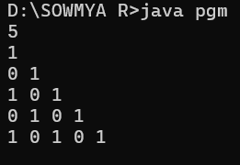

import java.util.Scanner;
public class pgm
{
public static void main(String[] args)
{
Scanner scanner = new Scanner(System.in);
int n = scanner.nextInt();
for (int i = n; i >= 1; i--)
{
for (int j = 1; j <= i; j++)
{
System.out.print(j+" ");
}
System.out.println();
}
}
}
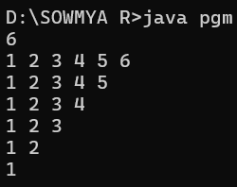

5.
import java.util.*;
import java.io.*;
public class pgm
{
public static void main(String args[])
{
Scanner n=new Scanner(System.in);
String a=n.nextLine();
switch(a)
{
case "Sunday":
System.out.println("Weekend");
break;
case "Monday":
case "Tuesday":
case "Wednesday":
case "Thursday":
case "Friday":
case "Saturday":
System.out.println("Weekday");
break;
default:
System.out.println("Invalid Input");
break;

}
}
}
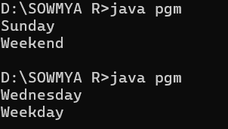
6.
import java.util.Scanner;
public class pgm
{
public static void main(String args[])
{
Scanner sc = new Scanner(System.in);
int a = sc.nextInt();
int fact,i,sum=0,rem;
int temp=a;
while(a!=0)
{
i=1;fact=1;
rem=a%10;
while(i<=rem)
{
fact=fact*i;
i++;
}
sum+=fact;
a=a/10;
}
if(temp==sum)
{
System.out.println("Strong number");
}
else
{
System.out.println("Not a Strong number");
}
}
}
